Design Challenge 2 Phase 1: Problem Exploration

Problem choice: Tiny Charts

Plan

I plan to explore how stacked bar charts can be dynamically scaled. My goal is to implement dynamic scaling of stacked bar charts to a live website using D3 (or maybe some other JavaScript library). This may also involve switching to some different type of chart, or even a summary statistic at very small scales.

The first thing I thought of when I saw the tiny charts project option was the New York Times’ use of tiny line charts arranged in the shape of the U.S. states they represent (screenshot below). This makes searching for and switching between states easy compared to a search bar to filter or linear scanning. It’s impressive that they fit 50 plots into one screen as effectively as this. It’s so effective that this is the only plot on their COVID page that’s not interactive, so it could be printed and work just as well.
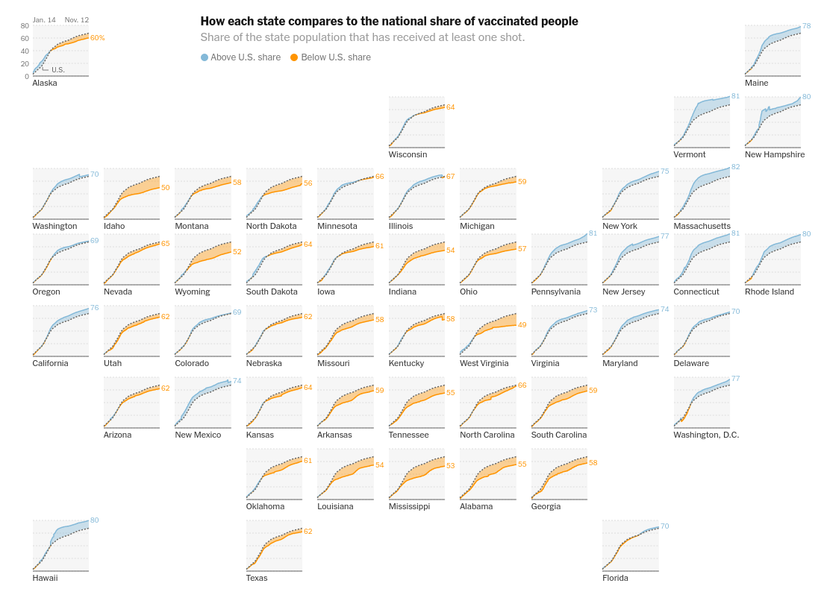

In addition to creating a dynamically scaling stacked bar chart, as the project requires, I would like to be able to make a visualization like this, but using stacked bar charts rather than line charts (and appropriate data).

I also think it’s interesting how, when arranging the small plots as the New York Times does, the line between 50 small plots and one big plot gets blurred. In the case of a stacked bar chart, I think this line would be even blurrier. At a certain scale, the most you can show is a single pixel color-encoding, which would effectively create a color-coded map of the United States. I would like to be able to create a smooth transition between many small state-level plots and one country-level plot.

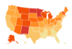

At a very small scale, the multiple line plots could be reduced to a color coded map, like this one.

Data

I plan to use U.S. election data, because:

- I’m interested in politics, elections, and especially election data
- It lends itself to stacked bar charts – portions of votes over multiple years, voter turnout, etc.
- Federal elections can be split up by state, and used to create a plot like the New York Times’ plot on page 1.
  - For an extra challenge, I could attempt to show every county in Wisconsin

I plan to use the MIT Election Data + Science Lab’s historical election data sets as my primary data source. I’ll primarily focus on U.S. Presidental Election data at first, but I may expand to others. I’m choosing this data source because it’s already parsed into csv files, it goes back a long time, and it’s from a trustworthy source.

I haven’t gotten far enough with D3 to make a default visualization with my data set. I suspect that it won’t be too bad at “medium” scales (200 px). I expect to have to work in both directions – both adding elements onto the default as it gets bigger and removing them as it gets smaller.

